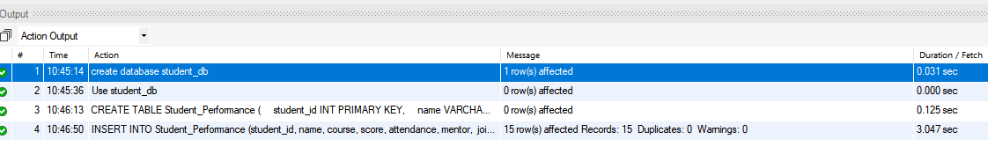

Question 1 : Create a ranking of students based on score (highest first).
Ans. SELECT student_id, name, score,
RANK() OVER (ORDER BY score DESC) AS student_rank
FROM Student_Performance;

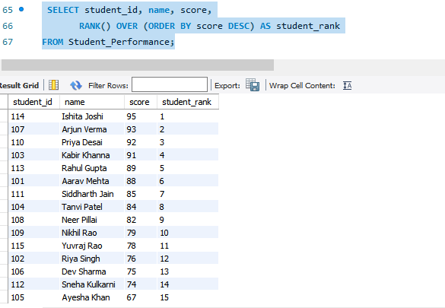

Question 2 : Show each student's score and the previous student’s score (based on score order).
Ans.
SELECT name, score,
LAG(score) OVER (ORDER BY score DESC) AS previous_score
FROM Student_Performance;
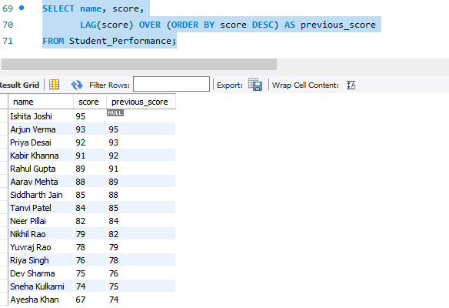

Question 3 : Convert all student names to uppercase and extract the month name from join_date.
Ans. SELECT UPPER(name) AS student_name,
MONTHNAME(join_date) AS month_name
FROM Student_Performance;
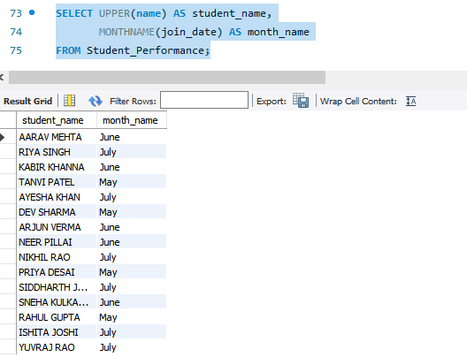

Question 4 : Show each student's name and the next student’s attendance (ordered by attendance).
Ans. SELECT name,
attendance,
LEAD(attendance) OVER (ORDER BY attendance) AS next_attendance
FROM Student_Performance;
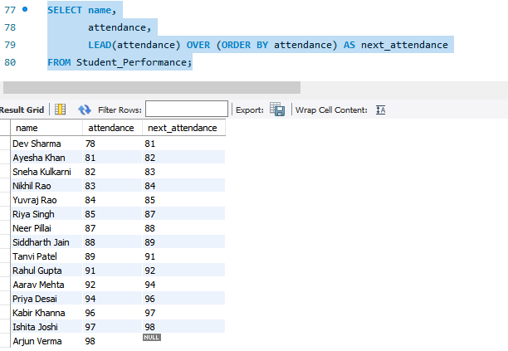

Question 5 : Assign students into 4 performance groups using NTILE().
Ans. SELECT name, score,
NTILE(4) OVER (ORDER BY score DESC) AS performance_group
FROM Student_Performance;
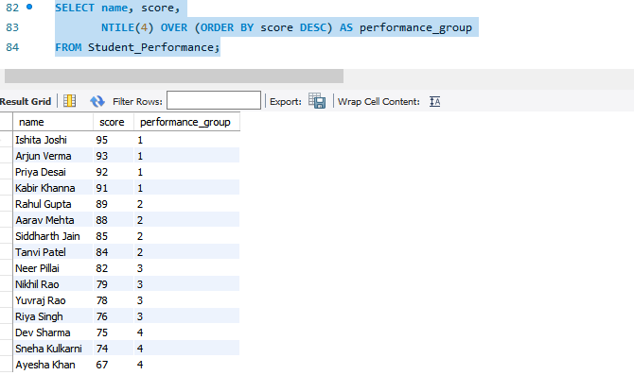

Question 6 : For each course, assign a row number based on attendance (highest first).
Ans. SELECT name, course, attendance,
ROW_NUMBER() OVER (
PARTITION BY course
ORDER BY attendance DESC
) AS row_num
FROM Student_Performance;

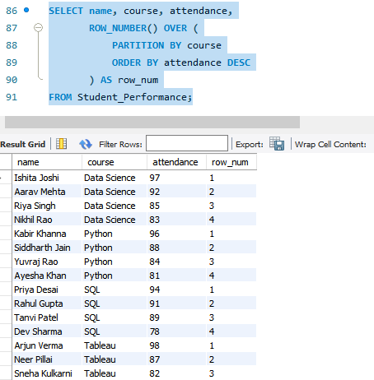

Question 7 : Calculate the number of days each student has been enrolled (from join_date to today). (Assume current date = '2025-01-01')
Ans. SELECT name,
join_date,
DATEDIFF('2025-01-01', join_date) AS enrolled_days
FROM Student_Performance;
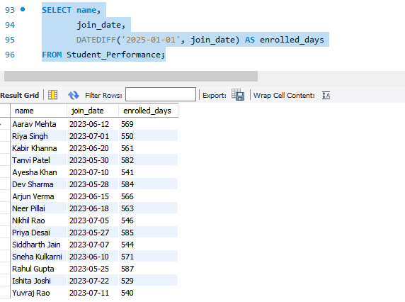

Question 8 : Format join_date as “Month Year” (e.g., “June 2023”).
Ans. SELECT name,
DATE_FORMAT(join_date, '%M %Y') AS formatted_date
FROM Student_Performance;
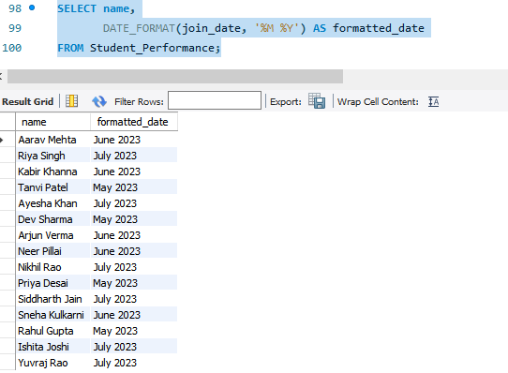

Question 9 : Replace the city ‘Mumbai’ with ‘MUM’ for display purposes.
Ans. SELECT name,
REPLACE(city, 'Mumbai', 'MUM') AS city_name
FROM Student_Performance;
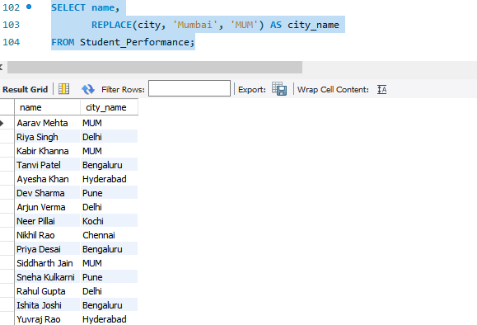

Question 10 : For each course, find the highest score using FIRST_VALUE().
Ans. SELECT name,
course,
score,
FIRST_VALUE(score) OVER (
PARTITION BY course
ORDER BY score DESC
) AS highest_score
FROM Student_Performance;

